

**Event Management at FPTU**

**Software Requirement Specification**

**Table of Contents**

I. Overview 3

1. Introduction 3

2. System Functions 4

3. Common Requirements 6

4. Data Dictionary 8

II. Functional Requirements 14

1. Login 14

a. Login 14

b. Check for role 14

2. Create event 14

3.Register event 16

# **I. Overview**

## **1. Introduction**

At FPT University every year, it is still difficult to help students access events, as well as clubs or departments, it is also difficult to manage all the events they organize. Therefore, the Event Management website was created to replace the traditional method to solve the above problems. the context diagram in the illustration of external entities and the system interface for this release.

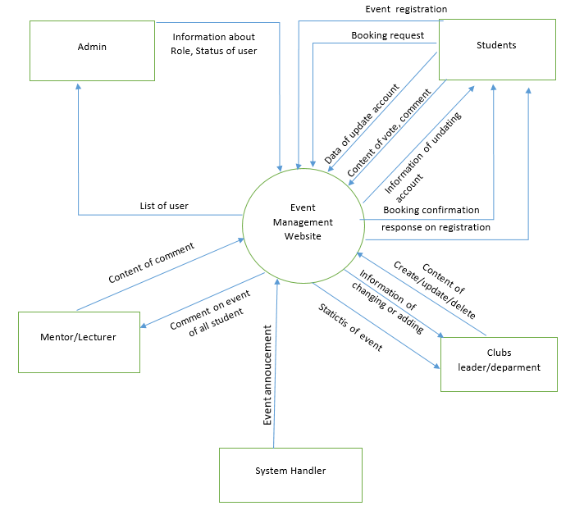

## **2. System Functions**

#### ***a. Screen Flow***

#### ***b. Screen Details***

| **#** | **Feature** | **Screen** | **Description** |
| --- | --- | --- | --- |
| 1 | Login with FPT email | Login, Gmail, HomePage | Click “login” button at homepage, choose fpt email to access website |
| 2 | View recent event | HomePage | View recent event with count down ( the nearest event and 3 recent event). |
| 3 | View all event | Event Page | View all event |
| 4 | Search event | Event Page | Search event by name/ price/ date/category |
| 5 | View event detail | Event Page, Event detail | Click on event , it will move to event detail page to see all detail of event like : price, date, ... |
| 6 | Register | Home Page, Event Page, Event Detail, | Click on “register event” button on post to register event |
| 7 | Confirm register | RegisterPage | Confirm all information of register and price |
| 8 | Payment | Register Page, Paypal page | Click “Payment “ button and select pay with Paypal to pay for ticket |
| 9 | Follow up event | Home Page, Event Page, Event Detail, | Click on icon “heart” on post to follow event |
| 10 | Update information | Profile | Click on icon “pencil “ to update information |
| 11 | View Schedule | Profile | View event registered and followed |
| 12 | Create Event | clubLeader, create page | Click on “create” button at Event Created to create new event |
| 13 | View statistic | clubLeader | Click on “statistic “ to see statistic of event |
| 14 | View list of register | clubLeader | Click on “User register “ to see list of register |
| 15 | ... | ... | …. |

#### ***c. User Authorization***

| **Screen** | **Guest** | **Attendee** | **Event Organizer** | **Administrator** |
| --- | --- | --- | --- | --- |
| Register by FPT’s email |  | X | X | X |
| Login and verify email |  | X | X | X |
| Follow up event |  | X | X |  |
| Booking ticket |  | X | X |  |
| Payment |  | X | X |  |
| Follow up schedule |  | X | X |  |
| Update information |  | X | X |  |
| View information |  | X | X |  |
| Search event | X | X | X |  |
| Comment |  | X | X |  |
| Vote, feedback |  | X | X |  |
| View vote, feedback |  |  | X |  |
| View history of event attended |  | X | X |  |
| Create event |  | X | X |  |
| View event detail | X | X | X |  |
| Update event |  |  | X |  |
| Delete event |  |  | X |  |
| View statistics of event |  |  | X |  |
| View list of event |  |  | X |  |
| View user Register |  |  | X |  |
| View Comment on post |  | X | X |  |
| Decentralization |  |  |  | X |
| Enable status for account |  |  |  | X |
| Receive notification email |  | X | X |  |
| View statistics of web |  |  |  | X |
| Logout |  | X | X | X |

In which:

* Attendee: FPT student, Lecturer/Mentor
* Guest : people who don’t have fpt email
* Event Organizer (FPT): club’s leaders, department managers,
* Administrator (FPT): lecturers/mentors, department managers

#### ***d. Non-Screen Functions***

| **#** | **Feature** | **System Function** | **Description** |
| --- | --- | --- | --- |
| 1 | Authentication | Login with Gmail |  |
| 2 | Notification | Notification |  |

## **3. Common Requirements**

| **No** | **Target** | **Common requirement** |
| --- | --- | --- |
| 1 | Students | Register account by email FPT  Search event by name/date/price/category  User-friendly interface, easy to use  Receive email notifications about events: successful registration, event canceled, banned, event information changed, ..  View the event calendar  View attended event  Follow up/ Register event  Online payment |
| 2 | Club member | Design the layout of the content  Search the event from 2 to 5 seconds  Improve the quality of the image |

## **Usability**

USE-1: The data is checked right on each field and immediately alerted if there is an error, avoiding forcing the user to enter it again and again.

USE-2: System pages are consistent with each other (in all pages, the nav bar will be preserved when the user scrolls),

USE-3: User can see available slots, date, comment, type of event and can click register or track event right outside instead of having to click on event details

USE-4 When registering for the event, the user will be redirected to the review page to review the information and choose a payment method (if it is a paid event) and the user only needs to click confirm, not need to fill in the information, because the information is taken directly from the user's personal information

USE-5- The system has 2 light and dark modes to match the user's usage context

## **Performance**

PER-1: The system can accommodate all students and lecturers of FPT University HCM (about 3000 users) and up to 100-200 concurrent users during the peak period of 9:00 AM to 10:00 AM local time, with an estimated average session duration of around 8-10p

PER-2: The system will send information to the user within an average of 3s and a maximum of 5s since the user sends the information to the system.

PER-3: 95% of the entire web page will be loaded within 3 seconds from the time the user requests the page over an internet connection of 20 Mbps or faster

## **Security**

## SEC-1: Guest can only view, and search for events

## SEC-2: The system only allows people who have logged in to the system to track and register to participate in the event

## SEC-3: For students who have not updated their personal information, the system will ask to update their information before registering for the event.

## SEC-4: Only students participating in the event can write feedback and vote for the event

## SEC-5: When a student makes an online payment, the system does not store the student's card information

## SEC-6: When the user is deactivated, the account must be sent to the admin to request for reactivation of the account

## **Safety**

## SAF-1: Users must see the items that will be held in the event they want to participate in to know if that event is suitable for their health or not.

## **Availability**

AVL-1: The Event Management shall be availabe available at least 98% of the time between 5:00 A.M. and midnight local time and at least 90% of the time between midnight and 5:00 A.M. local time, excluding scheduled maintenance windows

## **4. Data Dictionary**

| Data Element | Description | Composition or Data Type | Length | Values |
| --- | --- | --- | --- | --- |
| categoryID | Primary key of category table, id of category | int |  | Positive Number |
| categoryName | Name of category | nvarchar |  | Academy, play |
| clubID | Primary key of club table. Id of club | int |  |  |
| clubName | Name of each group in school | nvarchar(50) | 5 - 50 |  |
| clubDescription | More information about club like: date of establishment | ntext |  |  |
| clubEmail | Email for contact of club | varchar(30) | 10 - 30 |  |
| clubPhoneNumber | Main phone of club, sometimes it’s a phone number of club’leader | varchar(15) | 10 - 15 | +84xxxxxxxxx |
| registerID | Primary key of register table | int |  |  |
| registerDate | Date the user register account | date |  |  |
| statusID | Primary key of status table | int |  |  |
| statusDescription | More detail of status | nvarchar(30) | 5 - 30 |  |
| feedbackID | Primary key of feedback table | int |  |  |
| feedback | Content of feedback | ntext |  |  |
| vote | Show the like or dislike of user about event | float |  |  |
| followID | Primary key of follow table | int |  |  |
| eventID | Primary key of event table | int |  |  |
| eventName | Name of event | nvarchar(50) | 5 - 50 |  |
| createDate | Date create an event (create on website) | date |  | --/--/---- |
| startDate | Start date of event in organization | date |  | --/--/---- |
| endDate | End date of event | date |  |  |
| avgVote | Average of vote frome student after event occurred | float |  |  |
| imageURL | The link url of image | varchar(max) |  |  |
| content | Content of event | ntext |  |  |
| ticketFee | Fee of ticket | int |  |  |
| likeID | Primary key of like table | int |  |  |
| locationID | Primary key of location table | int |  |  |
| locationName | Name of place take place the event | nvarchar(30) | 5 - 30 |  |
| locationCapacity | Number of people who can attend | int |  |  |
| paymentID | Primary key of payment table | int |  |  |
| statusDecription | Status about payment:  uncompleted, pending, successful | varchar(30) | 5- 30 |  |
| paymentDate | Date user payment ticket | date |  |  |
| paymentTotal | Total of bill user have to pay | int |  |  |
| roleID | Primary key of role table | int |  |  |
| roleName | Name of role: student, lecture/mentor, club’s leader, department, admin | nvarchar(30) | 1-30 |  |
| userEmail | Email of user (fpt email) | varchar(30) | 10-30 | xxxxxx@fpt.edu.vn |
| userName | Full name of user | nvarchar(50) | 10-50 |  |
| dateOfBirth | Date of birth of user | date |  |  |
| gender | M= male, F= female, null = unknown | bit |  |  |
| phoneNumber | Phone number of user to contact | varchar(15) | 10-15 | +84xxxxxxxxx |
| statusID | Primary key of status table | int |  |  |
| statusDescription | ID have 2 status: active , unactive | nvarchar(30) | 5 ->30 |  |

# **II. Functional Requirements**

## **1.Login**

### **a. Login**

Trigger: Click your email FPT.

Description: Unauthenticated users (or Guests) can log into the system using an Account.

Layout:

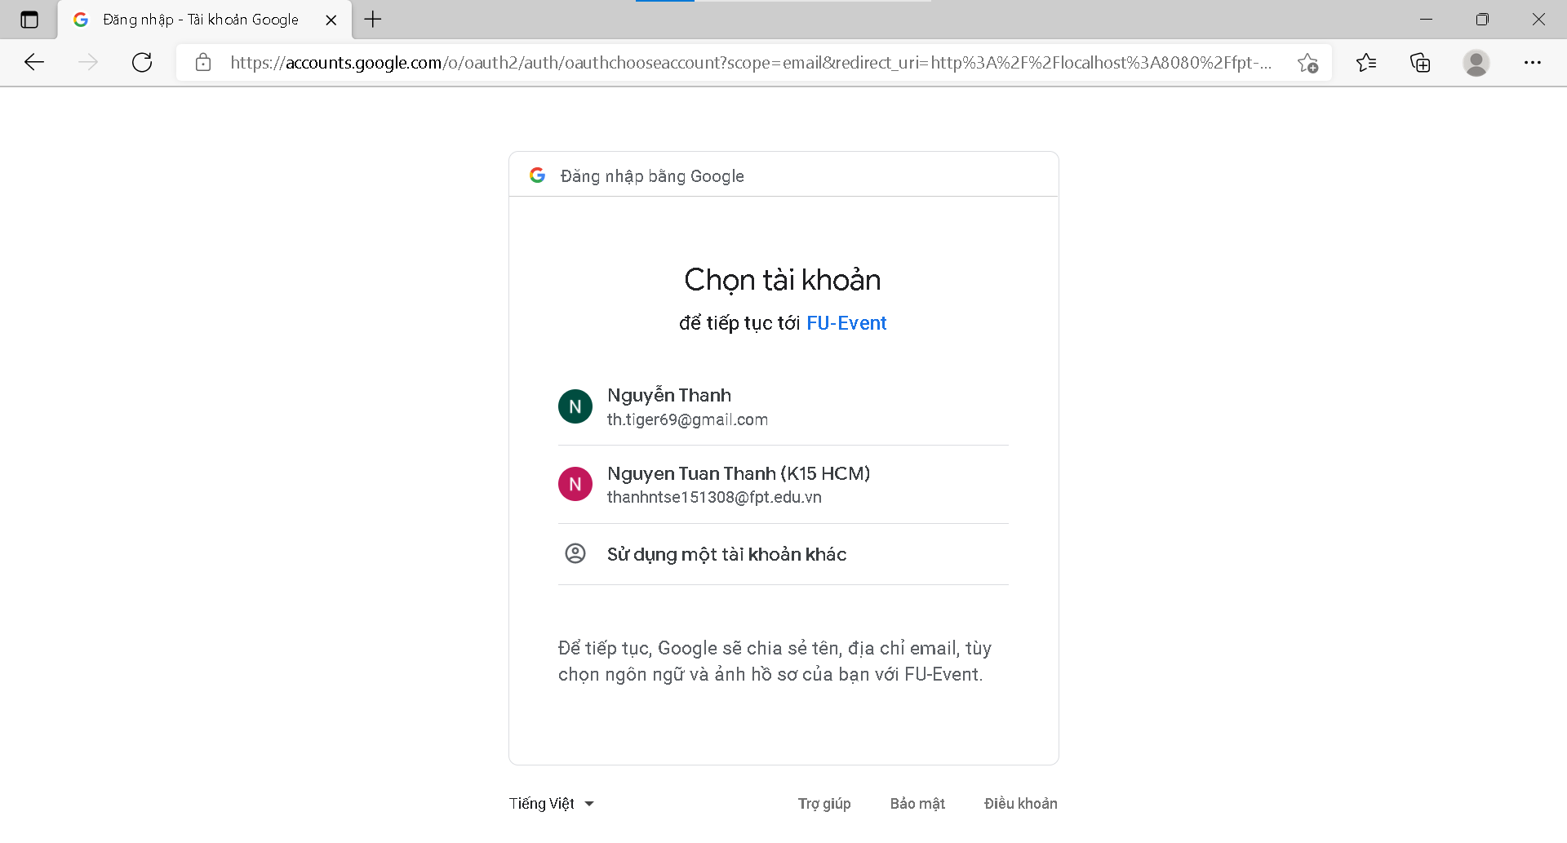

Details:

* Data:
* Business logic:
* Functionalities:

### **b. Check for role**

Trigger: Automatically after login or before performing Admin tasks

Description: Is a function that check for the required role to display certain views or to confirm before actions that might take critical effects for the user or the system.

Layout: N/A

Details:

* Data
* Validation
* Business logic:
* Functionalities:

## **2. Create Event**

Trigger: Create event

Description: Club leader or Department management can create new Events to contribute to the community.

Layout:

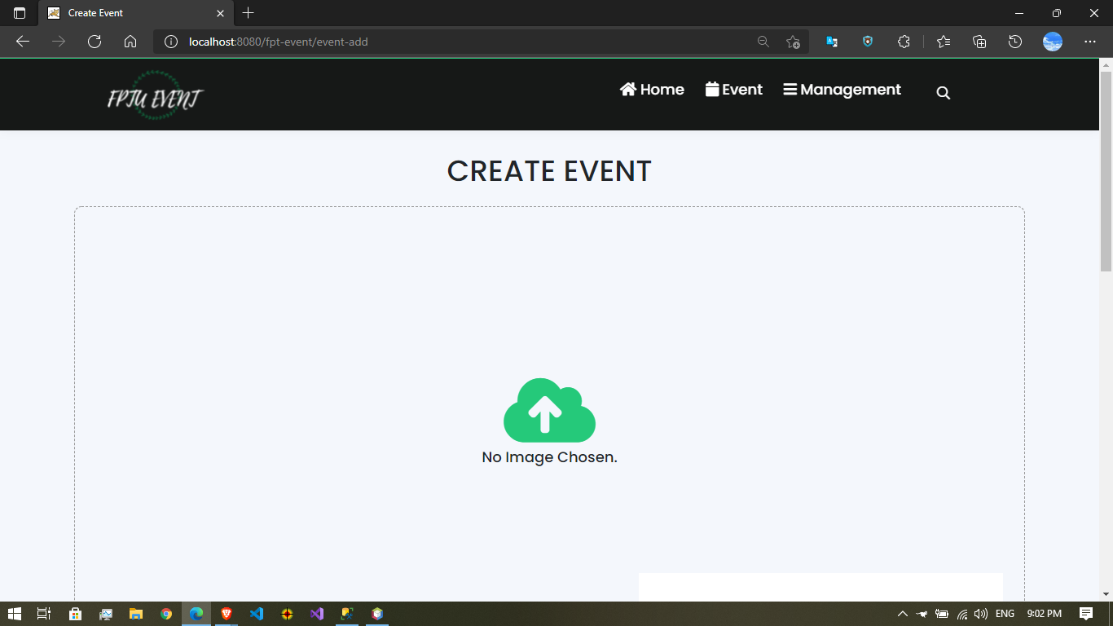

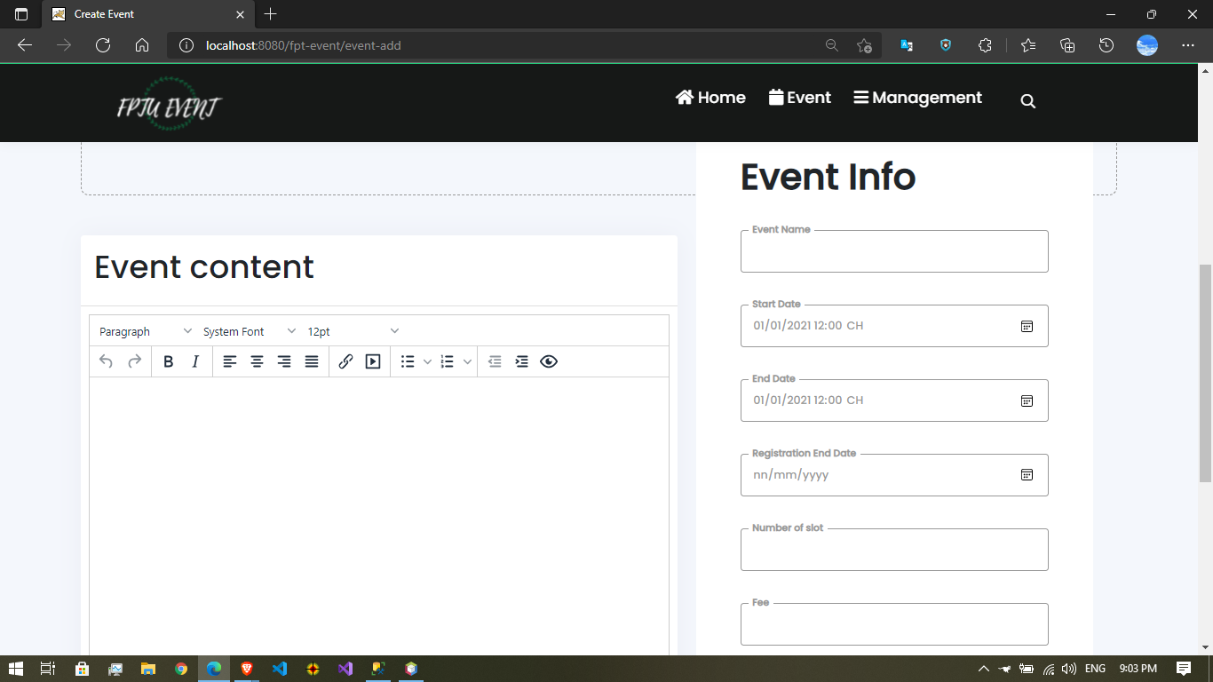

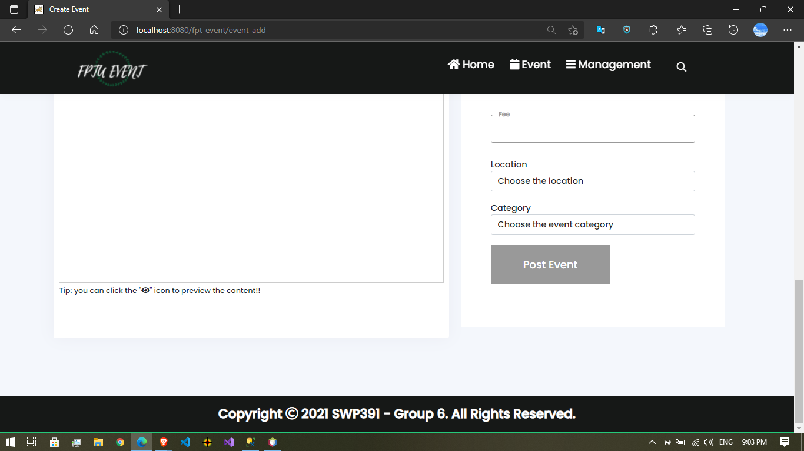

Details:

* Data
* Validation
* Business logic:

Created Event needs to have an Image of event , Content of event and Event Info. Start Date must before End Date.

* Functionalities:

## **3. Register Event**

Trigger: Follow event

Description: Student , Lecture/Teacher can follow existing events. Club leader or department manager can only follow events of another club.

Layout: 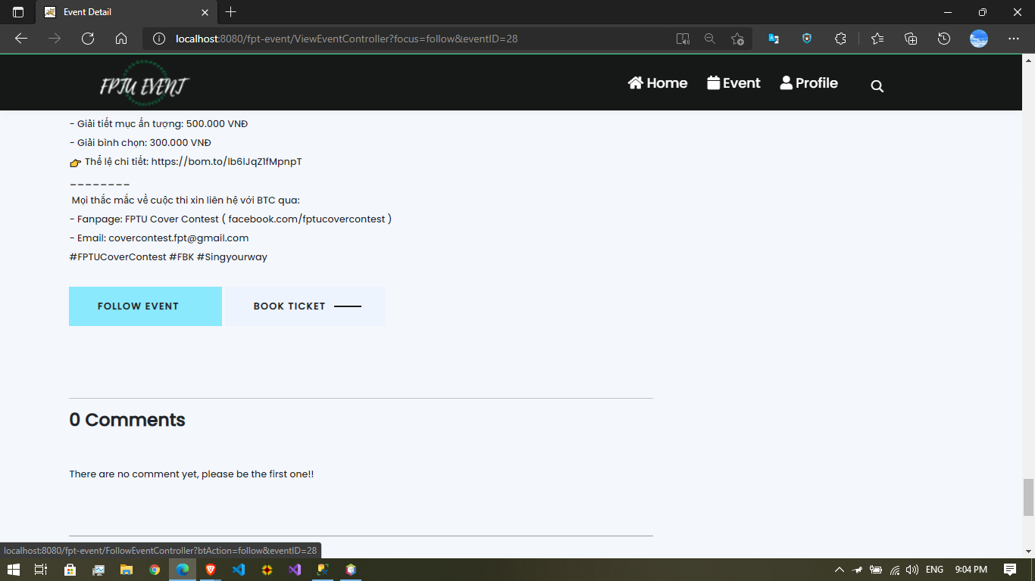

Details:

* Data
* Validation
* Business logic:
* Functionalities: